ATHE Extended Diploma in Computing

Name of the Unit

Student Name:
Learner ID:
Qualification:
Level :
Unit Code:
Centre Name: | LEXICON School Of Business And Finance

LEXICON School of Business and Finance

Table of Contents
Task 1 3
Key programming paradigm 3
Language construct 3
Key differences 4
Task 2 5
Introduction 5
Overview of functionality 5
Ticket pricing and calculation 6
User interface design 6
User interface mock-ups 7
Conclusion 8
Extension activities 8
Justification 8
Task 3 10
Code 10
Demonstration 10
Improving integrity 10
Test plan 10
Analysis 11
User testing 11
Extension activities 12
Version control primer 12
Recommendations 12
Distinction 13
Evaluation of version control 13
Evaluation of solution 13
Appendices 14

Task 1

Key programming paradigm
Programming paradigms characterize the methodology and approach used to compose programs, and the four primary ideal models are procedural, object-arranged, utilitarian, and occasion driven programming. Procedural programming follows an organized, hierarchical methodology where capabilities and strategies characterize a program's stream, making it simple to peruse and troubleshoot, as found in dialects like C and Python. Object-arranged programming (OOP) sorts out code into objects containing information and strategies, following standards like embodiment, legacy, and polymorphism, which upgrade code viability and versatility, as found in Java, C++, and Python. Useful programming regards calculation as the assessment of numerical capabilities, staying away from alterable state and after-effects, utilizing recursion and higher-request capabilities to further develop code consistency, with dialects like Haskell, Stutter, and Python supporting this methodology. Occasionally driven programming, generally utilized in graphical UI (GUI) applications, answers client collaborations, for example, snaps or key presses, using occasion controllers to upgrade responsiveness, making it pervasive in JavaScript and Python GUI systems. Every worldview offers unmistakable benefits, and Python's adaptability permits designers to take on different standards inside a solitary venture, making it a flexible language for different applications.

Language construct
Python offers a few language builds that work with organized and proficient programming, including factors, information types, control structures, capabilities, classes, and special case taking care of. Factors store values, and Python upholds dynamic composing, permitting them to hold various information types like whole numbers, strings, records, and word references. Control structures like restrictive articulations (if-else) and circles (for, while) oversee program stream, empowering navigation and emphasis. Capabilities advance code reusability and modularization, permitting designers to characterize reusable rationale blocks utilizing def explanations, with worked in capabilities and libraries further improving capacities. Object-situated programming in Python utilizes classes and protests to exemplify information and conduct, cultivating code association and reusability. Exemption taking care of with attempt aside from blocks oversees runtime blunders nimbly, forestalling program crashes and further developing power. Python's different builds make it a strong language for both straightforward prearranging and complex application improvement.

Key differences
Programming and scripting are firmly related however have particular contrasts in reason, intricacy, and execution. Programming includes planning and growing undeniable applications that require organized rationale, information the executives, and advancement, regularly written in aggregated dialects like C, Java, or C++. Conversely, prearranging is fundamentally utilized for mechanizing dreary undertakings, designing frameworks, and interfacing different programming parts, frequently using deciphered dialects like Python, JavaScript, or Slam. Programming requires greater preparation and investigating, as projects are normally created for enormous scope use, while scripts are lightweight and implied for fast execution without complex computer programming processes. For example, a Python program may be utilized to fabricate a web application utilizing Flagon, requiring various modules and conditions, while a Python content may be utilized to computerize record renaming in a registry with only a couple of lines of code. This qualification makes programming ideal for creating programming items, while prearranging upgrades efficiency via mechanizing routine errands.

Task 2

Introduction
The Electronic Ticketing System for the Centrala Underground means to modernize charge assortment by presenting a protected, effective, and easy to use computerized stage. This framework will supplant conventional paper tickets with contactless computerized other options, decreasing lines and functional expenses while further developing traveller experience. By consolidating QR codes, NFC innovation, and constant information synchronization, the framework guarantees consistent travel, upgraded security, and viable administration of travel tasks.

Overview of functionality
The Electronic Ticketing System for the Centrala Underground offers a consistent and easy to understand insight by permitting travellers to choose their boarding and objective zones. It consequently works out the all out zones voyaged and decides the passage appropriately. The framework upholds different traveller classifications, including Grown-up, Kid, Senior, and Understudy, guaranteeing fair valuing. When the charge is determined, it is shown prior to giving a computerized travel voucher with the date and time, empowering a problem free and proficient driving experience.

Ticket pricing and calculation
The ticket evaluating for the Centrala not entirely settled by the quantity of zones a traveller goes through, increased by the individual charge per traveller type. For Grown-ups, the admission is 2105 Pennies for every zone, while Kids are charged 1410 Pennies for each zone. Seniors partake in a decreased toll of 1025 Pennies for each zone, and Understudies are charged 1750 Pennies for every zone. This estimating structure guarantees a fair and reasonable travel experience customized to various traveller classes, with straightforward computations in light of the excursion's length, advancing openness and comfort for all.

User interface design
The UI Plan of the Electronic ticketing system guarantees a smooth and natural experience for travellers. The Stations Board noticeably shows the accessible zones and stations, permitting clients to distinguish their movement choices without any problem. The Menu Choice element empowers clients to helpfully choose their beginning and objective zones. An Information Structure catches fundamental traveller subtleties, including classes like Grown-ups, Youngsters, seniors, and Understudies. When the subtleties are presented, the framework creates a Voucher Show showing the ticket subtleties, toll breakdown, and aggregate sum, giving an unmistakable and straightforward synopsis of the charge and excursion data.

User interface mock-ups
The UI Mock-ups for the Electronic Ticketing System are intended for clearness and usability. The Fundamental Menu Screen includes a zone determination interface, where clients can pick their boarding and objective zones effortlessly. The Traveller Info Screen prompts clients to choose the quantity of voyagers from classifications like Grown-ups, Kids, seniors, and Understudies, guaranteeing precise charge estimation. When the subtleties are placed, the Voucher Show screen shows a passage breakdown with an unmistakable outline of expenses, all out charge, and excursion subtleties. Furthermore, clients are given a choice to print their movement voucher for comfort.

Conclusion
The Electronic Ticketing System upgrades the effectiveness and openness of travel administrations while guaranteeing straightforwardness in toll computations. The subsequent stages being developed incorporate coordinating instalment doors, executing ongoing ticket approval, and leading client testing to refine the framework. Moreover, a versatile application rendition could be created to extend openness and further develop client comfort.

Extension activities

Justification
The plan choices for both the usefulness and the UI of the Electronic Ticketing System centre on upgrading client experience, proficiency, and availability. The usefulness is custom-made to improve on the tagging system by offering zone determination, which straightforwardly integrates with straightforward charge computation. The charge breakdown guarantees travellers comprehend the costs in view of their movement zones and traveller type (e.g., Grown-up, Youngster, Senior, and Understudy), advancing reasonableness and clearness. Supporting different traveller class guarantees moderateness for different gatherings.
For the UI, the main menu Screen was intended to be natural, permitting travellers to choose zones with a visual portrayal of accessible stations without any problem. The Traveller Information Screen is organized to gather the vital subtleties in a straightforward, easy to understand structure. The Voucher Show screen sums up the ticket subtleties and gives a print choice to comfort. By and large, the plan choices focus on usability, clearness, and a proficient stream beginning to end, guaranteeing a consistent encounter for clients.

Task 3

Code
Refer to the ticket_system.py file

Demonstration
In this arrangement, a few coding guidelines are applied to work on the comprehensibility and practicality of the code. Unmistakable and significant names are utilized for factors and works, observing Enthusiasm 8 rules, for example, display stations board, get zone choice, and calculate fares. Blunder taking care of is integrated utilizing attempt and aside from blocks to oversee invalid client inputs, guaranteeing strength. The code is separated into little, secluded capabilities, each zeroing in on a solitary undertaking, which helps with comprehensibility, troubleshooting, and testing. Also, remarks are added to explain the capability and rationale of the code, helping future designers comprehend and adjust it easily.

Improving integrity
To work on the respectability of information sources, approval is applied at key stages in the program to guarantee exact and dependable information. In the first place, the zone choice guarantees the client enters a legitimate zone number (somewhere in the range of 1 and 4) by really taking a look at that the info falls inside this reach. Second, the explorer data is approved to guarantee that the quantity of voyagers for every class (Grown-ups, Youngsters, seniors, and Understudies) is a non-negative whole number. On the off chance that a negative number is placed, the client is incited to enter a legitimate worth. Third, charge estimations guarantee that the quantity of zones voyaged is positive and not zero, forestalling wrong admission calculation. Also, all charge estimations are checked to guarantee they don't bring about bad qualities. These approval measures keep up with the framework's trustworthiness by keeping invalid information from being handled, diminishing mistakes and guaranteeing the precise age of movement vouchers.

Test plan
The test plan for the ticketing system will incorporate different kinds of testing to guarantee that the usefulness, rationale, information designs, and all capabilities are tried completely. In the first place, unit testing will be led to approve individual capabilities like calculate fares, get zone choice, and generate voucher. Each capability will be tried with different sources of info, including limit cases (e.g., choosing the first and last zones), invalid data sources (e.g., negative numbers, non-whole number qualities), and edge cases like zero voyagers or zero zones voyaged. Then, reconciliation testing will guarantee that the parts associate flawlessly, particularly the stream from client contribution to passage estimation and voucher age. Experiments will incorporate choosing various blends of start and objective zones, fluctuating quantities of voyagers, and checking for right charge computations for every traveller type.
Information approval tests will check in the event that invalid information inputs, like negative numbers for explorers or out-of-range zone numbers, are accurately dismissed. Furthermore, execution testing will be led to guarantee the program runs effectively with an enormous number of sources of info. At long last, client acknowledgment testing will reproduce genuine utilization by checking assuming that the framework meets utilitarian prerequisites like showing the right voucher, exact passage breakdowns, and legitimate blunder dealing with. The test plan will likewise remember similarity testing to check the program's exhibition for various stages.

Analysis
Test results will be contrasted with the normal results to distinguish errors. In the event that the program neglects to create the right passage estimations, erroneous voucher subtleties, or misuses invalid data sources, it will demonstrate a bug in the rationale or info approval capabilities. Any bungled outcomes, for example, erroneous passage breakdowns or mistakes in zone choice, will set off a survey of the comparing capabilities. Remedial activities will incorporate investigating the impacted code, improving information approval, and guaranteeing that edge cases are dealt with appropriately. Also, assuming execution issues are distinguished, advancement of the code might be important to improve effectiveness.

User testing
User testing includes having true clients communicate with the ticketing system to evaluate its convenience and usefulness. A different gathering of clients, addressing different traveller types (Grown-ups, Kids, seniors, Understudies), is chosen. They are approached to perform different undertakings, for example, choosing substantial and invalid zones, entering voyager subtleties, and ascertaining admissions for various zone blends. Noticing clients as they cooperate with the framework recognizes ease of use difficulties, for example, confounding directions or mistake messages. Subsequent to testing, client input is gathered with respect to the framework's instinct and execution. In view of this criticism, any issues, as mistaken information taking care of or hazy route, are tended to. The framework is then refined by further developing mistake messages, improving approval, and enhancing the UI, guaranteeing a more consistent and solid experience for all clients.

Extension activities

Version control primer
Git command | Purpose
Git init | Helps in initializing a new git repository in the desired project folder
git clone <repository-url> | Helps in copying an existing repository which is remote
Git status | Depicts the current state of the directory
Git add <file> | Committing a specific file
Git add | Changed files for commit
Git commit –m “message” | Saves changes
Git branch | Creates a new branch
Git checkout | Helps in switching to the specified branch
Git merge | Merges a branch in current one
Git log | Displays commit history
Git diff | Depicts difference between the versions of file

Recommendations
While giving over a product arrangement, critical to give exhaustive programming documentation fills in as an aide for future designers, framework managers, and clients. Documentation ought to remember clear directions for the framework's design, the motivation behind each capability, and any arrangements required. For mix, guarantee that any conditions are indisputable and that APIs or outer administrations are made sense of. The establishment and sending cycles ought to be illustrated bit by bit, including arrangement for various conditions (improvement, testing, creation), and any server or framework prerequisites. For progressing upkeep, it's vital for offer direction on the most proficient method to add new highlights —, for example, integrating extra zones or stations — by refreshing the information structures and altering significant code segments. Suggestions ought to likewise cover testing techniques, investigating steps, and rules for fixing security weaknesses. By setting up a reasonable handover bundle, including gritty guidelines and future-sealing ideas, you guarantee smooth changes and long haul outcome in keeping up with and scaling the product.

Distinction

Evaluation of version control
Version control is important in the improvement of coded arrangements, as it empowers productive following and the executives of changes made to the code base. It gives an organized way to deal with designers to team up, guaranteeing that every change is recorded, alongside the creator and timestamp. This straightforwardness makes it simpler to pinpoint mistakes or clashes that emerge and works with rollback to past stable variants if necessary. Adaptation control likewise upholds spreading, permitting numerous engineers to chip away at isolated highlights without upsetting the primary task. Moreover, it improves on coordinated effort by empowering colleagues to flawlessly combine their work. Devices like Git make this cycle considerably more impressive by coordinating with stages like GitHub and GitLab, cultivating better correspondence and smoothed out code surveys. Eventually, variant control further develops code quality, diminishes chances, and guarantees coherence being developed.

Evaluation of solution
The arrangement meets the first client brief by giving an easy to use electronic ticketing system that really computes charges in light of zone determination and traveller type, with clear passage breakdowns. The program permits clients to pick start and objective zones, input voyager subtleties, and get an exhaustive travel voucher. It sticks to the predetermined usefulness, offering exact admission computations for various traveller types — grown-ups, kids, seniors, and understudies — in view of the quantity of zones voyaged. Notwithstanding, future enhancements could incorporate more vigorous mistake taking care of, coordination with instalment frameworks, and a graphical UI for better client experience. In general, the arrangement lines up with the centre targets, however further improvements could upgrade adaptability and client commitment.

Appendices
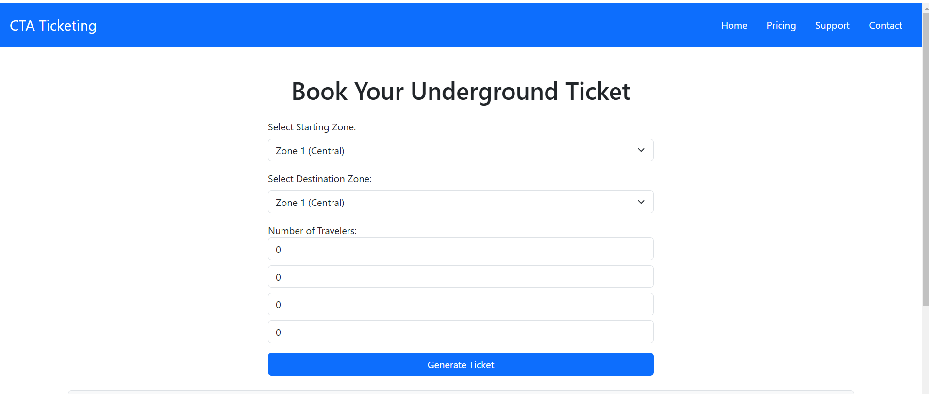
UI Design

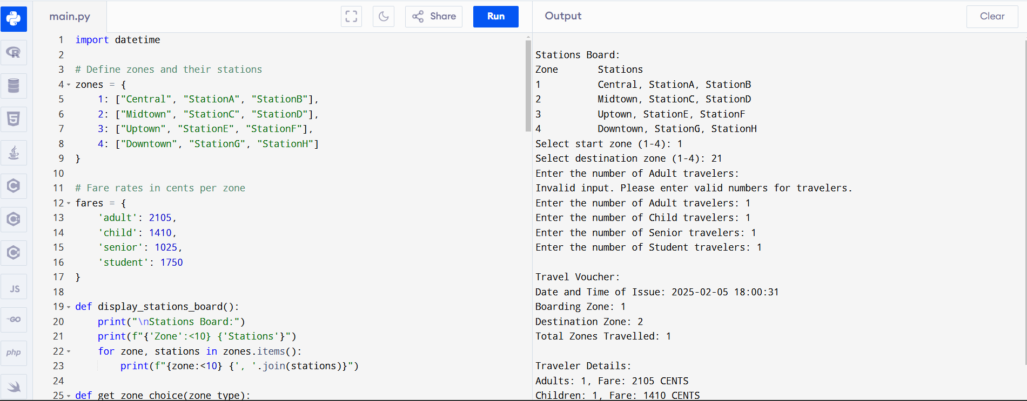Code for ticket system

